**Department of Electronics and Communication Engineering**

**Shavige Malleshwara Hills, Kumaraswamy Layout, Bengaluru – 560 078.**

**(An Autonomous Institute affiliated to VTU, Approved by AICTE )**

|  |  |
| --- | --- |
| Program: B.E. | Branch: ECE |
| Course: Digital Signal Processing | Semester : 4 |
| Course Code: 22EC43 | Date: 10/07/2024 |

**A Report on**

**Compare frequency response of FIR filter using various window function in SIMULINK/MATLAB**

**Submitted by**

|  |  |  |  |
| --- | --- | --- | --- |
| **Sl. No.** | **USN** | **NAME** | **MARKS** |
| 1. | 1DS22EC132 | MOHANA B N |  |
| **2** | 1DS22EC138 | NAGALAKSHMI S |  |
| **3** | 1DS22EC140 | NAINA BHANDARI |  |
| **4** | 1DS22EC141 | NANDANI KUMARI |  |

Faculty In-charge

Dr. Vinay N A

**Signature of Faculty In-charge**

**AIM:**

**Compare frequency response of FIR filter using various window**

**function in SIMULINK/MATHLAB.**

**INTRODUCTION:**

Digital signal processing often involves designing Finite Impulse Response (FIR) filters to meet specific frequency domain requirements. FIR filters are characterized by their impulse response, which is finite in duration, making them computationally efficient and offering desirable properties such as linear phase response.

A critical aspect of FIR filter design is the choice of window function applied to the filter coefficients. Window functions shape the frequency response and influence important parameters such as main lobe width, side lobe levels, and stop-band attenuation. Common window functions include the Hamming, Hanning.

In this study, we aim to compare the frequency responses of FIR filters employing various window functions using SIMULINK/MATLAB. By visualizing these frequency responses, we can evaluate how different window functions affect the filter's performance in terms of frequency selectivity, pass-band ripple, stop-band attenuation, and overall shape of the frequency response curve.

This comparison will provide insights into the practical implications of window function selection in FIR filter design, helping to guide engineers and researchers in choosing the most suitable window function for their specific signal processing applications.

Top of Form

Bottom of Form

**Matlab program:**

clc;

clear all; close all; n=20; fp=200; fs=600; f=1000; wp=2* (fp/f)

WS=2*(fs/f)

wn= [wp, ws ]

%window=boxcar(n+1); % rectangular window %window=bartlett(n+1);% traiangular window %window=hamming (n+1);% hamming wondow %window= hanning (n+1);% hanning window window= kaiser(n+1); % kasiser window wn=2*(fp/fs)

/b=fir1(n, wn, window)

b=fir1(n,wn, 'high', window)

[H,w]=freqz(b, 1)

subplot (2,1,1)

plot(w/pi, 20*1og(abs(H)))

xlabel( 'nf')

ylabel ('mag in dB' )

title("mag response")

subplot (2,1,2)

plot(w/pi, angle(H))

xlabel('nf')

ylabel ( 'mag in dB')

title("phase response")

**SIMULINK DIAGRAM:**

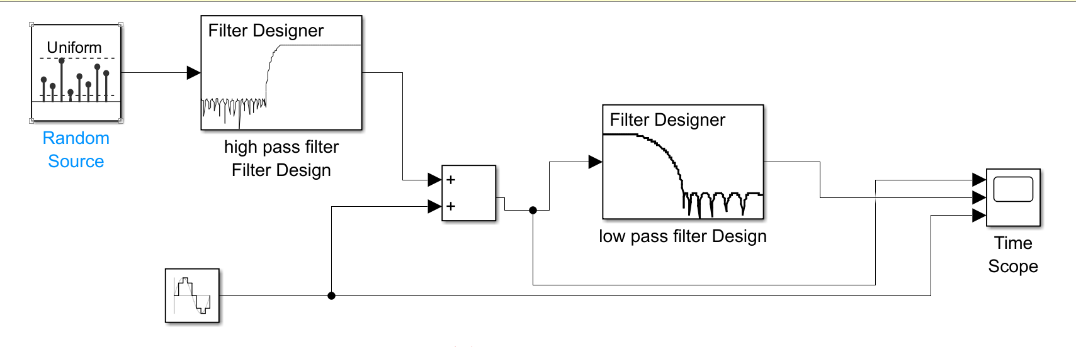

**FILTERS PARAMETERS:**

**Response Type Lowpass**

**Design Method - FIR, Equiripple**

**Filter Order Minimum order**

**Units Normalized (0 to 1)**

**wpass = 0.2**

**wstop=0.5**

**Click Design Filter at the bottom of the app to design the filter.**

**➤ Your Digital Filter Design block now represents a filter with the parameters you specified.**

**From the Edit menu, select Convert Structure.**

**The Convert Structure dialog box opens.**

**Select Direct-Form FIR Transposed and click OK.**

**Rename your block Digital Filter Design - Lowpass.**

**Create a Highpass Filter in Simulink**

**Double-click the Digital Filter Design block. The filter designer app opens.**

**Set the parameters as follows:**

**Design Method FIR, Equiripple**

**wstop=0.2**

**Filter Order Minimum order**

**Units Normalized (0 to 1)**

**wpass 0.5**

**Design - Highpass.**

**Filter High-Frequency Noise in Simulink**

**Add block:**

**List of signs=+++**

**\* Icon shape rectangular**

**Minimum0**

**Source type Uniform**

**Random Source block:**

**Maximum = 4**

**Sample time 1/1000**

**Sample mode = Discrete**

**➤ Sine Wave block:**

**Samples per frame = 50**

**Frequency (Hz) = 75**

**Sample time 1/1000**

**Samples per frame = 50**

**➤ Time Scope block:**

**File > Number of Input Ports > 3**

**View > Configuration Properties. Open the Time tab and set Time span = One frame**

**period**

**Connect the blocks as shown in the following figure. You might need to resize some of the blocks to accomplish this task.**

**In the Modeling tab, click Model Settings. The Configuration Parameters dialog box opens.**

**Start time = 0**

**In the Solver pane, set the parameters as follows, and then click OK:**

**Type = Fixed-step**

**Stop time = 5**

**Solver = Discrete (no continuous states)**

**In the Simulation tab, select Run. The model simulation begins and the scope displays the three input signals**

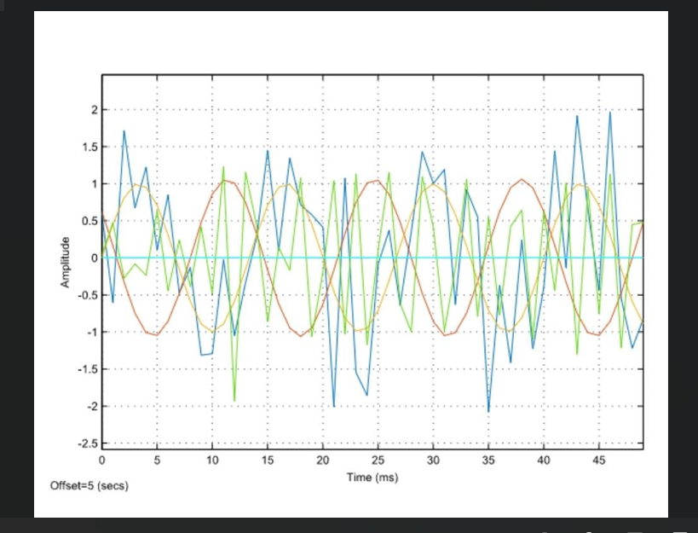

**RESULTS AND DISCUSSION:**

### 1. Comparative Analysis:

#### a. ****Trade-offs and Applications****:

* **Frequency Selectivity vs. Side Lobe Suppression**: Hamming and Hanning windows provide moderate frequency selectivity with acceptable side lobe levels, suitable for general-purpose filtering. Blackman and Kaiser windows offer enhanced side lobe suppression but with broader main lobes, catering to applications requiring stringent out-of-band signal rejection.
* **Stop-Band Attenuation**: Blackman and Kaiser windows demonstrate superior stop-band attenuation due to their effective side lobe suppression, crucial for applications needing robust attenuation of unwanted frequencies.

#### b. ****Practical Considerations****:

* **Computational Complexity**: The choice of window function impacts computational requirements, with more complex windows (e.g., Kaiser) potentially requiring higher computational resources.
* **Ease of Implementation**: MATLAB/Simulink simulations facilitate straightforward implementation and visualization of FIR filter frequency responses, aiding in comparative analysis and decision-making for practical applications.

### 2. Visualization and Insight:

* MATLAB plots of frequency responses clearly illustrate the differences between window functions in terms of main lobe width, side lobe levels, and stop-band attenuation.
* Visual insights provide engineers with a tangible understanding of how each window function influences filter performance, guiding optimal selection based on specific application requirements.

**CONCLUSION:** In conclusion, the choice of window function profoundly influences the efficacy of FIR filters in DSP applications. By leveraging MATLAB/Simulink for comprehensive analysis and visualization, engineers can effectively optimize filter designs to meet specific frequency domain requirements, ensuring robust performance in diverse signal processing environments.